**Assignment 1**

Analyze a given business scenario and create an ER diagram that includes entities, relationships, attributes, and Cardinality. Ensure that the diagram reflects proper normalization up to the third normal form.

# Business Scenario:

A company needs to keep track of the following information:

1. Employees: Each employee has a unique employee ID, name, age, and salary.
2. Departments: Each department has a unique department ID, department name, and location.
3. Works_in: Each employee works in one department.

# ER Diagram Description:

Entities:

1. Employees: employee_id (PK), name, age, salary, department_id (FK)
2. Departments: department_id (PK), department_name, location Relationships:
   * Works_in: An employee works in a department (one-to-many relationship). Cardinality:
3. One department can have multiple employees (one-to-many relationship).
4. An employee works in only one department (many-to-one relationship).

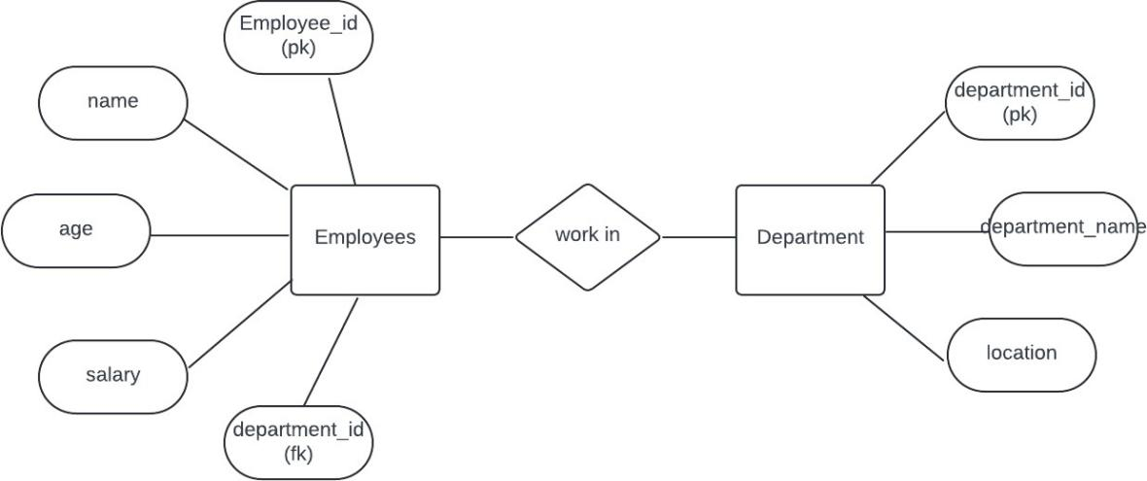

Relationships:

* + Departments (1) - (N) Employees: A department can have multiple employees working in it.

This ER diagram accurately represents the company database, reflecting proper normalization up to the third normal form, and clearly defines the entities, relationships, attributes, and Cardinality.